REFERENCE ARCHITECTURE — v1.0
Agentic Engineering Platform
A vendor-neutral, reusable blueprint for multi-agent software engineering — Greenfield and Brownfield, built to scale to thousands of engineers
Companion to: Agentic SDLC Advisory Roadmap (SystemC engagement)
Audience: Platform engineers, solution architects, CTOs evaluating build-vs-buy
Date: 27 June 2026
Why this document exists, separately from the roadmap
The roadmap answers “what order should SystemC adopt agentic engineering in.” This document answers a different question: “what does the platform underneath that adoption actually look like, precisely enough to build or evaluate it.” It is written to be reusable beyond any single client — the patterns here hold whether the consuming organisation has 100 engineers or 10,000.

Contents
Contents 2
1. Architecture Principles 3
2. System Context (C4 Level 1) 4
3. Containers (C4 Level 2) 5
3.1 Why specialist agents never call each other directly 5
4. Components — Inside the Orchestrator (C4 Level 3) 6
5. Core Platform Concerns 7
5.1 Agent Registry — dynamic discovery 7
5.2 Tool Registry — external integrations 7
5.3 Shared Memory & Project Context 7
5.4 Event-Driven Communication 7
5.5 Task Queue & Workflow Engine 7
5.6 Human Approval Checkpoints 7
5.7 Audit Logs & Explainability 8
5.8 Multi-Tenant Architecture 8
5.9 Security, RBAC & Secrets 8
5.10 Cost Optimisation & Model Routing 8
5.11 Failure Recovery & Retry 8
5.12 Metrics, Observability & Governance 8
6. Agent Contract 9
7. Tool Contract 10
8. Task Schema 11
9. Memory Schema 12
10. Event Model 13
10.1 Core event types 13
11. Workflows 14
11.1 Greenfield Product Development 14
11.2 Brownfield Modernization 15
11.3 Production Defect Resolution 15
11.4 Remaining Workflows — Comparison Matrix 16
12. Deployment Architecture 18
13. Scalability Strategy 19
14. Reference Implementation Roadmap — 5,000+ Engineer Enterprise 20

(If section titles don't appear above, right-click and choose “Update Field” — standard Word behaviour for a Table of Contents.)

1. Architecture Principles
Six tenets shape every decision in this document. Where a later section seems to add complexity, it traces back to one of these.
Principle | What it rules out
Agents never call agents | All communication is event-mediated. Rules out tight coupling that breaks every time one agent's interface changes.
Orchestrator plans, never executes | The orchestrator decomposes and routes; it never writes code, runs a scan, or makes a judgement call itself. Keeps the core stable as specialist agents change.
New agents plug in, never patch in | Adding a capability means registering a new agent against the Agent Registry contract — never editing orchestrator code. This is the platform's actual scalability claim.
Humans approve, agents propose | Every workflow has named, non-bypassable approval gates. Rules out “fully autonomous” framing anywhere safety, cost, or compliance is at stake.
Every decision is reconstructable | If an auditor or incident review asks “why did this happen,” the answer is a query against the audit store, not a guess.
Vendor-neutral by construction | Tool Registry and Model Router exist specifically so Azure DevOps today doesn't mean a rebuild if the client uses Jira tomorrow, and Claude today doesn't mean lock-in if a model swap makes sense later.

2. System Context (C4 Level 1)
The platform sits between the people who request and approve work, and the external systems that already hold an enterprise's code, tickets, and infrastructure. It introduces no new system of record — it orchestrates the ones that exist.

Figure 1 — System Context: people, the platform, a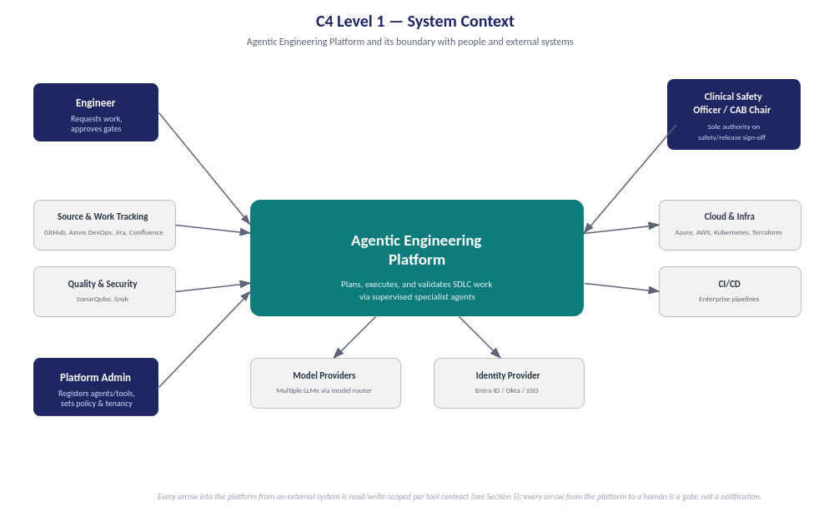nd the external systems it integrates with
Two relationships are deliberately asymmetric. Arrows into the platform from GitHub/Azure DevOps/Jira/SonarQube/Snyk are read/write per a scoped Tool Contract (Section 7) — never blanket credentials. Arrows from the platform to the Clinical Safety Officer / CAB Chair (or equivalent governance role in a non-healthcare client) are gates, not notifications: the workflow cannot proceed past that point without a recorded decision.

3. Containers (C4 Level 2)
Nine containers, each independently deployable and independently scalable. The Event Bus is the only thing every other container talks to — this is what makes the platform's plug-in claim real rather than aspirational.
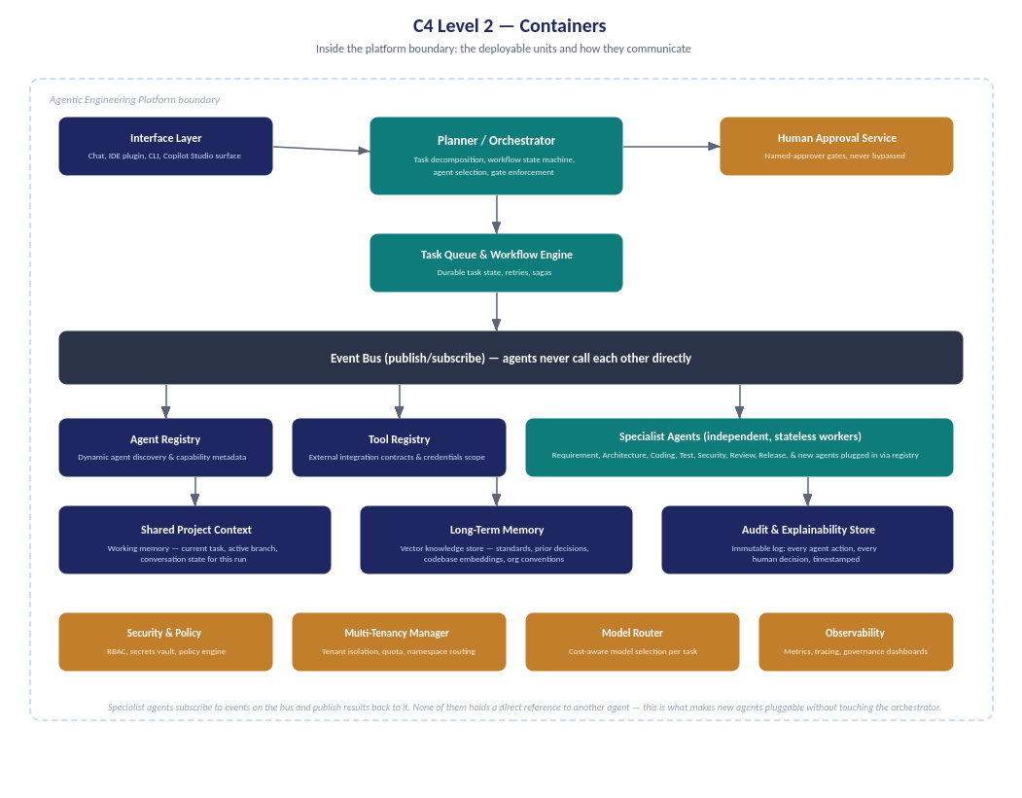
Figure 2 — Containers inside the platform boundary

3.1 Why specialist agents never call each other directly
This is the single most consequential design decision in the platform, so it's worth justifying explicitly. If the Coding Agent called the Test Agent directly, every new agent added later would need to know about every agent that might call it — an O(n²) coupling problem that gets worse with every capability the platform gains. Routing everything through the Event Bus means an agent has exactly one relationship to maintain: publish results, subscribe to relevant events. A thousand-engineer platform with fifty specialist agents is exactly as architecturally simple as a five-agent pilot.

4. Components — Inside the Orchestrator (C4 Level 3)
Zooming into the one container most readers will ask about first: how does the orchestrator actually decide what to do.
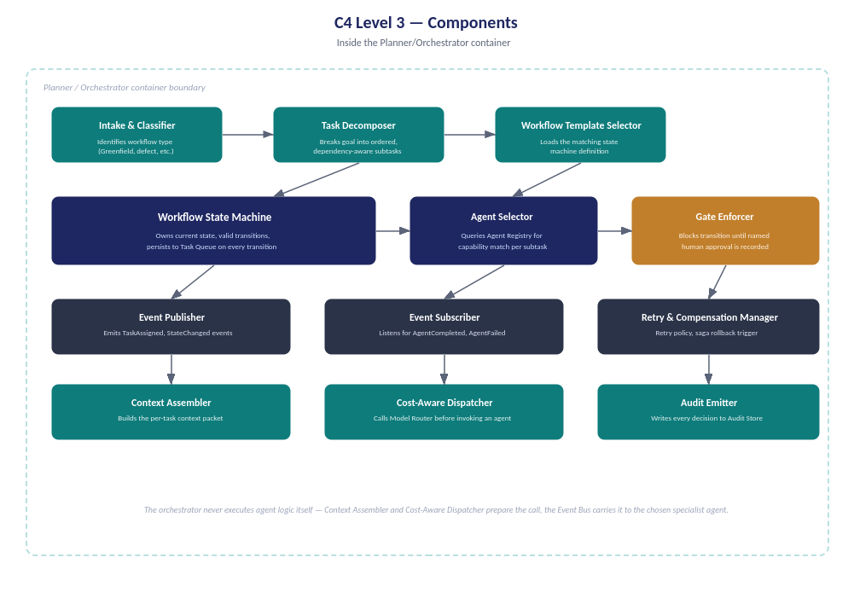
Figure 3 — Components inside the Planner/Orchestrator
Note what's absent: there is no component here that writes code, runs a test, or scans a dependency. The Context Assembler prepares what a specialist agent will need; the Cost-Aware Dispatcher decides which model tier the work justifies before dispatch; the Gate Enforcer's only job is to refuse to advance workflow state until a recorded approval exists. The orchestrator is a planner and a referee, never a player.

5. Core Platform Concerns
The fifteen concerns below are not separate features bolted together — each is a thin, well-bounded responsibility, deliberately kept separate so that scaling or replacing one never forces a rewrite of another.

5.1 Agent Registry — dynamic discovery
Every specialist agent registers its capabilities, input/output schema, and resource cost class at startup — it is never hardcoded into the orchestrator. The orchestrator's Agent Selector queries this registry by capability tag (e.g. “generates-unit-tests”, “scans-dependencies”), not by agent name. Adding a new agent is an entry in this registry, not a code change.

5.2 Tool Registry — external integrations
Every external system (GitHub, Azure DevOps, Jira, Confluence, Kubernetes, Terraform, SonarQube, Snyk, enterprise CI/CD) is wrapped in a Tool Contract (Section 7) registered here. Agents request a tool by capability (“create-pull-request”), and the registry resolves it to whichever concrete integration the tenant has configured. This is the entire mechanism behind vendor neutrality — a tenant using Jira instead of Azure DevOps changes a registry entry, not agent logic.

5.3 Shared Memory & Project Context
Two distinct memory types, often conflated incorrectly:
- Working context (short-lived): the active task, branch, and conversation state for the current run — passed explicitly between agents per the Task Schema (Section 8), not silently shared.
- Long-term memory (durable): a vector knowledge store holding coding standards, architecture decisions, prior incident resolutions, and codebase embeddings — queried by any agent that needs organisational context, written to deliberately, not automatically.
Conflating these is the most common cause of agents producing inconsistent output across runs — working context that should have been discarded leaking into what looks like institutional memory.

5.4 Event-Driven Communication
All inter-agent communication is publish/subscribe over the Event Bus, using the Event Model defined in Section 10. An agent publishes what it did; it never instructs another agent on what to do next — that sequencing logic lives solely in the orchestrator's Workflow State Machine.

5.5 Task Queue & Workflow Engine
Durable, persisted task state — not in-memory. Every workflow transition is written before it's acted on, so a platform restart resumes mid-workflow rather than losing state. Implements retry-with-backoff per task and saga-style compensation for multi-step rollback (Section 11.3's rollback strategies depend on this).

5.6 Human Approval Checkpoints
A first-class platform service, not a UI afterthought. Every gate produces a named-approver record (who, when, what they saw, what they decided) before the workflow state machine is permitted to transition. Gates can be time-boxed (Section 11.3, defect resolution) or open-ended (Section 11.1, architecture review) — the platform supports both, but every gate is non-bypassable by design.

5.7 Audit Logs & Explainability
An immutable, append-only store of every agent action and every human decision, each tied to a task ID, a workflow run, and a timestamp. This is what turns “trust the AI” into “query the record” — the same mechanism that satisfies an internal retro also satisfies an external compliance audit.

5.8 Multi-Tenant Architecture
Tenancy is enforced at three layers: namespace isolation in the Task Queue and Memory stores (one tenant's project context is never visible to another's agents), per-tenant policy configuration (which gates are mandatory, which tools are permitted), and per-tenant quota on the Model Router. A single platform deployment can serve multiple business units or multiple clients without code forking.

5.9 Security, RBAC & Secrets
Three distinct controls, often wrongly merged into one: RBAC governs which humans can approve which gates; the Policy Engine governs which actions an agent is permitted to take regardless of who's asking; the Secrets Vault means no agent or tool integration ever holds a credential directly — it requests a short-lived, scoped token per invocation.

5.10 Cost Optimisation & Model Routing
Not every task needs the most capable (and most expensive) model. The Model Router classifies each dispatched task by complexity and risk, and routes accordingly — a routine test-scaffold generation task and a security-critical architecture review should not cost the same or use the same model tier. This is also the platform's primary lever for managing inference spend at scale.

5.11 Failure Recovery & Retry
Three tiers, escalating: automatic retry with backoff for transient failures (a flaky API call), saga-style compensation for partial multi-step failures (Section 11.2's increment-by-increment rollback), and escalation to a human gate when retries exhaust — the platform never silently gives up or silently keeps trying forever.

5.12 Metrics, Observability & Governance
Three audiences, three views of the same underlying event stream: engineers see task-level tracing (what did the agent actually do); engineering leadership sees DORA metrics aggregated across workflows; governance/compliance sees the audit trail filtered to gate decisions. One observability backbone, not three separate tools.

6. Agent Contract
Every specialist agent — present or future — implements the same contract shape. This uniformity is what makes Section 5.1's “plug in without touching the core” claim real rather than marketing language.
Field | Type | Purpose
agent_id | string (unique) | Stable identity used in registry lookups and audit records
capabilities | string[] (tags) | What the orchestrator's Agent Selector matches against — e.g. “generates-unit-tests”
input_schema | schema reference | Shape of the context packet this agent expects (see Task Schema, Section 8)
output_schema | schema reference | Shape of the result this agent publishes back to the Event Bus
required_tools | string[] (tool capability tags) | Which Tool Registry entries this agent needs resolved before it can run
cost_class | enum: low / medium / high | Default hint to the Model Router — overridable per task
approval_required | boolean | Whether this agent's output must pass a Human Approval Checkpoint before the next state transition
idempotency_key_strategy | function reference | How this agent ensures a retried invocation doesn't duplicate side effects

7. Tool Contract
Every external system integration — GitHub, Azure DevOps, Jira, Confluence, Kubernetes, Terraform, SonarQube, Snyk, or a CI/CD platform — is wrapped identically, regardless of how different the underlying vendor API is.
Field | Type | Purpose
tool_id | string (unique) | Stable identity, e.g. “github-prod” or “azure-devops-tenant-a”
capability_tags | string[] | What an agent requests — e.g. “create-pull-request” — resolved to this concrete tool
auth_strategy | enum: OAuth / PAT / managed-identity | How the Secrets Vault issues a scoped, short-lived credential for this tool
scope | enum: read / write / admin | Least-privilege ceiling — enforced regardless of what the underlying credential could technically do
rate_limit_policy | object | Prevents one tenant's agent activity from exhausting a shared API quota
response_normaliser | function reference | Maps vendor-specific responses to a common shape agents consume — this is what makes swapping Jira for Azure DevOps Boards invisible to agent logic

8. Task Schema
The unit of work passed between the orchestrator and any specialist agent. Every workflow in Section 11 is a sequence of these.
Field | Type | Purpose
task_id | string (unique) | Correlates this task across events, logs, and audit records
workflow_run_id | string | Which end-to-end workflow instance this task belongs to
workflow_type | enum (Section 11 list) | Greenfield, Brownfield, defect-resolution, etc. — selects the state machine template
context | object | The working-context packet assembled by the Context Assembler — prior agent outputs relevant to this task
assigned_agent_id | string | Resolved by the Agent Selector against the Agent Registry
state | enum (per workflow) | Current position in the workflow's state machine (Section 11 defines states per workflow)
retry_count | integer | Drives the Retry & Compensation Manager's escalation decision
approval_record | object | null | Populated only once a Human Approval Checkpoint has been satisfied for this task

9. Memory Schema
Long-term memory is a vector store with structured metadata — retrieval is never a blind similarity search.
Field | Type | Purpose
memory_id | string (unique) | Stable identity for this memory entry
embedding | vector | Used for semantic similarity retrieval
source_type | enum: standard / ADR / incident / codebase | Lets an agent filter retrieval by what kind of memory it actually needs
tenant_id | string | Enforces the multi-tenancy isolation boundary at the memory layer itself, not just at the API layer
recency_weight | float | Lets newer architecture decisions outrank stale ones without deleting history
provenance | object | Which task/workflow run wrote this memory — makes long-term memory itself auditable

10. Event Model
Every event on the bus follows one envelope shape, regardless of which agent or service emits it. Specific event types below are the vocabulary specialist agents and the orchestrator use to coordinate without ever calling each other.
Envelope field | Purpose
event_id, event_type, timestamp | Standard identity and ordering metadata
task_id, workflow_run_id | Correlates this event back to the Task Schema (Section 8) that triggered it
emitted_by | agent_id or service name — always attributable, never anonymous
payload | Event-type-specific body (e.g. a diff, a test report, an approval decision)

10.1 Core event types
Event type | When it fires
TaskCreated | Orchestrator decomposes a workflow step into a task and publishes it for the assigned agent
AgentStarted / AgentCompleted / AgentFailed | Lifecycle of a specialist agent's execution — AgentFailed triggers the Retry & Compensation Manager
ApprovalRequested / ApprovalGranted / ApprovalDenied | Human Approval Checkpoint lifecycle — ApprovalDenied routes back into the workflow as a revision task, not a dead end
StateTransitioned | Workflow State Machine moved from one defined state to the next — the canonical record consumed by Observability
RollbackTriggered | Compensation logic activated — carries which task/increment is being reverted and why

11. Workflows
Eight workflow types share the same platform primitives — the same orchestrator, the same Agent/Tool Registries, the same event vocabulary. What differs is the state machine each one loads, the agents it engages, and where its approval gates sit. Three are detailed in full below for maximum contrast; the remaining five share enough structure with these three that a comparison table (Section 11.4) is the more honest way to present them than mechanically repeating seven sub-sections five more times.

11.1 Greenfield Product Development
No legacy constraints — the Architecture Agent designs from a clean slate, and gates exist to confirm direction early, before code exists, rather than to catch problems after.
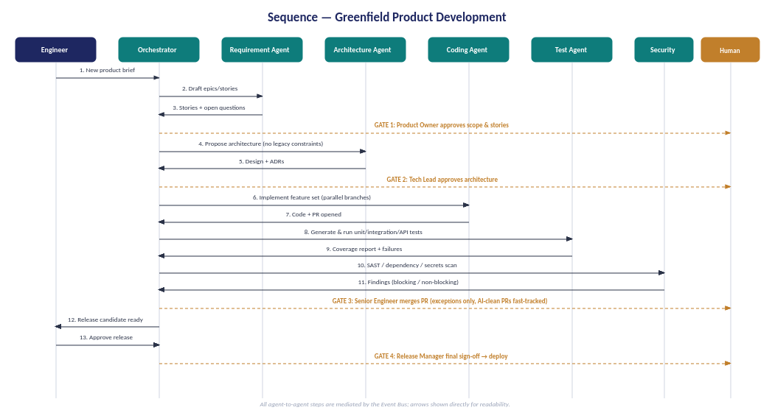
Figure 4 — Greenfield sequence: requirement through release
Participating agents | Requirement, Architecture, Coding, Test, Security, Review, Release
State transitions | Scoped → Architected → Implemented → Tested → Scanned → Merged → Released
Context passed forward | Stories+acceptance criteria → ADRs+API contracts → diff+PR → coverage report → scan findings → release candidate
Human gates | (1) Product Owner approves scope, (2) Tech Lead approves architecture, (3) Senior Engineer merges (exceptions only), (4) Release Manager final sign-off
Rollback strategy | Pre-merge: discard branch, no production impact. Post-release: standard CI/CD rollback to prior release artifact — no Greenfield-specific complexity since nothing legacy depends on this code yet
Success criteria | Cycle time from approved scope to release candidate; % of PRs merged without human-found defects; zero unreviewed code reaching production

11.2 Brownfield Modernization
This is the workflow that most clearly answers “how do Greenfield and Brownfield differ” — the difference isn't which agents exist, it's the order they run in and what has to happen before any code changes.
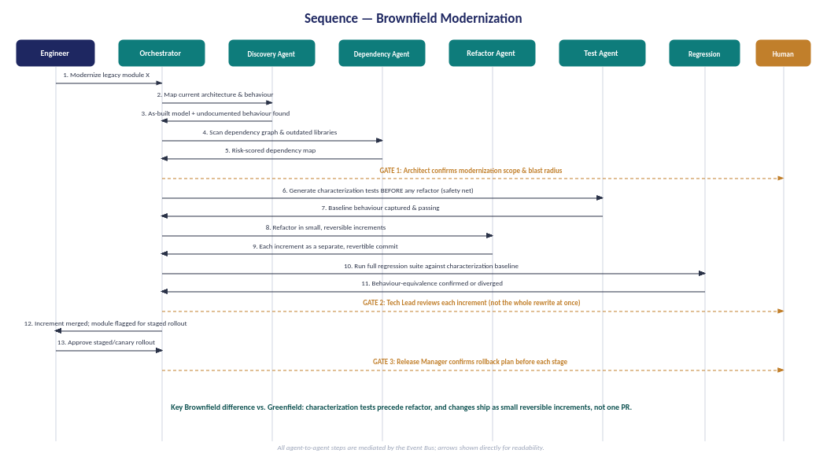
Figure 5 — Brownfield sequence: discovery and characterization precede refactor
Participating agents |  | Discovery, Dependency Analysis, Refactor, Test, Regression
State transitions |  | Discovered → Dependency-Mapped → Scope-Confirmed → Characterized → Refactored (per increment) → Regression-Verified → Staged
Context passed forward |  | As-built model+undocumented behaviour → risk-scored dependency map → characterization test baseline → incremental diffs → regression results
Human gates |  | (1) Architect confirms scope+blast radius, (2) Tech Lead reviews each increment individually — not the whole rewrite, (3) Release Manager confirms rollback plan before each staged rollout
Rollback strategy |  | Per-increment, not per-project: each refactor step is a separate, independently revertible commit, verified against the characterization baseline captured before any change — a failed increment reverts without touching the others
Success criteria |  | Behavioural equivalence maintained (zero characterization-test regressions); dependency risk score trending down; no big-bang cutover — staged rollout completion rate
The Greenfield/Brownfield difference, stated plainly
Greenfield's gates protect a decision (scope, architecture) before work is built on top of it. Brownfield's gates protect a behaviour (what the legacy system already does, undocumented or not) before anything is allowed to change it. The Discovery and Dependency Analysis agents, and the characterization-test-before-refactor sequencing, have no Greenfield equivalent because there is nothing yet to discover.

11.3 Production Defect Resolution
The workflow most likely to be stress-tested by both engineers and executives, because it runs under real time pressure with a live incident attached.
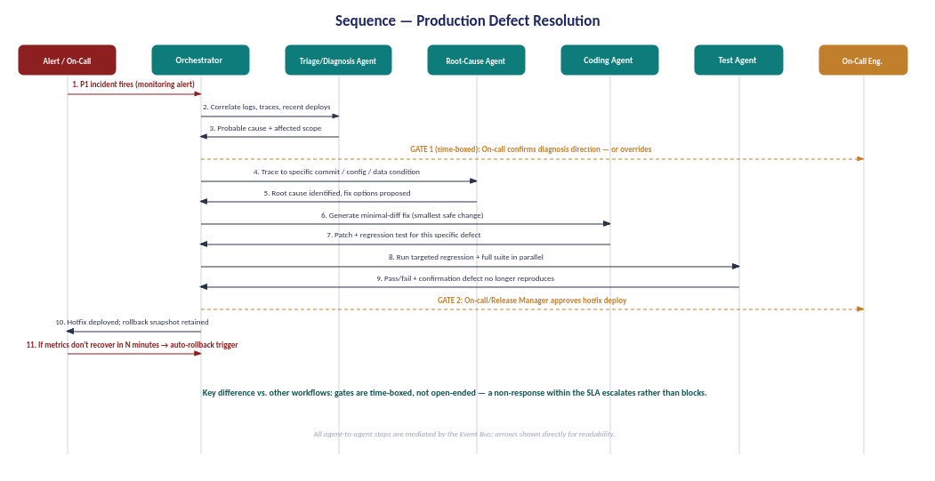
Figure 6 — Defect resolution sequence: time-boxed gates, automatic rollback on non-recovery
Participating agents |  | Triage/Diagnosis, Root-Cause, Coding, Test
State transitions |  | Alerted → Triaged → Root-Cause-Identified → Patched → Verified → Deployed → (Monitoring → Stable | Rolled-Back)
Context passed forward |  | Alert+correlated telemetry → probable cause+scope → root cause+fix options → minimal diff+targeted test → verified hotfix
Human gates |  | (1) On-call confirms diagnosis direction — time-boxed, escalates to senior on-call if no response within SLA, (2) On-call/Release Manager approves hotfix deploy
Rollback strategy |  | Automatic, not gated: a rollback snapshot is taken at deploy time, and if monitored metrics don't recover within N minutes, rollback triggers without waiting for a human — the one workflow in this platform where speed of reversal outweighs the cost of a false-positive rollback
Success criteria |  | Mean time to resolution (MTTR); % of incidents where AI-proposed root cause matched confirmed cause; rollback false-positive rate kept low enough that on-call trusts the automatic trigger
Why this workflow's gates are time-boxed and others aren't
Greenfield and Brownfield gates are open-ended because the cost of waiting for a thoughtful human decision is low relative to the cost of an irreversible mistake. A live P1 inverts that calculus — an open-ended gate here just means a longer outage. Time-boxing the gate, with automatic escalation on non-response and automatic rollback on non-recovery, is what makes “human approval everywhere” compatible with an SRE's actual SLA.

11.4 Remaining Workflows — Comparison Matrix
These five reuse the same orchestrator, registries, and event vocabulary as the three detailed above. What's distinctive about each is captured here rather than repeated at full length.
Workflow | Participating agents | Key gate | Rollback approach
Feature Enhancement | Requirement, Architecture (impact-analysis mode), Coding, Test, Review | Tech Lead confirms the change doesn't violate existing architecture invariants | Same as Greenfield — feature-flagged where the change touches a high-traffic path
Security Remediation | Security (Snyk/SAST-integrated), Root-Cause, Coding, Test | Security Lead approves the fix doesn't introduce a new finding while closing the original | Time-boxed like defect resolution for actively-exploited CVEs; open-ended for low-severity findings
Technical Debt Reduction | Discovery, Refactor, Test, Documentation | Engineering Manager prioritises which debt items enter a sprint — the platform proposes, doesn't self-schedule | Identical to Brownfield's per-increment revertible commits
Legacy Migration | Discovery, Dependency Analysis, Migration (platform-specific), Test, Regression | Architect approves the target-platform mapping before any migration begins — highest-stakes gate in the platform | Dual-run/parallel-run period before legacy decommission — the only workflow with a built-in “keep both running” phase
Release Management | Release-Readiness, Documentation, Security (final scan) | Release Manager + (where applicable) Clinical Safety/CAB sign-off — the gate every other workflow eventually feeds into | Standard CI/CD rollback to prior release artifact, informed by whichever upstream workflow's rollback already ran

12. Deployment Architecture
Vendor-neutral does not mean cloud-agnostic at the infrastructure layer — it means the platform's core containers (Section 3) are built on portable primitives so the same platform deploys on Azure or AWS without an architecture change, only a configuration one.
Container | Azure-native option | AWS-native option
Orchestrator / Agents | AKS (Kubernetes) or Azure Container Apps | EKS (Kubernetes) or ECS Fargate
Event Bus | Azure Service Bus / Event Grid | Amazon EventBridge / SQS+SNS
Task Queue & Workflow Engine | Durable Functions or a workflow engine on AKS | Step Functions or a workflow engine on EKS
Long-Term Memory (vector store) | Azure AI Search (vector mode) or self-hosted pgvector on Azure Postgres | Amazon OpenSearch (vector) or self-hosted pgvector on RDS Postgres
Secrets Vault | Azure Key Vault | AWS Secrets Manager
Identity / RBAC | Microsoft Entra ID | AWS IAM Identity Center
Observability | Azure Monitor + Log Analytics | CloudWatch + OpenTelemetry collector
Infra-as-code | Terraform (azurerm provider) | Terraform (aws provider)

Terraform is the deliberate constant across both columns — it's the one infrastructure layer where being vendor-neutral by construction (Principle 6, Section 1) costs nothing, since the platform was always going to need infra-as-code regardless of cloud.

13. Scalability Strategy
Three different things get conflated under “scale,” and the platform addresses them differently.
Scaling dimension | Mechanism
More engineers using the platform | Stateless specialist agents scale horizontally behind the Event Bus — adding load means adding agent replicas, not redesigning workflow logic
More capabilities (new agent types) | Agent Registry growth — each new agent is an independent registration, never a change to the orchestrator or to existing agents (Section 5.1)
More tenants / business units | Namespace isolation at the Task Queue and Memory layers (Section 5.8) — one platform deployment, many isolated tenants, not one deployment per tenant

The honest limit
This architecture scales the platform's capacity to coordinate work. It does not, by itself, scale the judgement quality of any individual agent — a Coding Agent built on a weaker model doesn't improve because the platform around it is well-architected. Model capability and platform capability are separate investments, and Section 5.10's Model Router is the lever for the former, not a substitute for it.

14. Reference Implementation Roadmap — 5,000+ Engineer Enterprise
This is deliberately a different roadmap from the SystemC advisory document — that one is phased by organisational trust-building for one client; this one is phased by what the platform technically needs to exist before the next layer can be built safely.
Stage | Build | Why this order
0. Platform spine | Event Bus, Task Queue, Agent Registry, Tool Registry, Audit Store | Nothing else in this document works without these five — they are the contract every later piece depends on
1. First vertical slice | Orchestrator + 2-3 agents (e.g. Requirement, Coding, Test) on one real workflow, one pilot team | Proves the spine under real load before any second team depends on it — mirrors the SystemC Phase 1–2 pattern, generalised
2. Multi-tenancy | Namespace isolation, per-tenant policy config, quota on Model Router | Must exist before a second business unit onboards — retrofitting tenancy after multiple teams share state is materially harder than building it first
3. Full agent catalog | Remaining specialist agents (Section 11) registered; all 8 workflow templates loaded | Safe to add now because Stage 0–2 already proved an agent can be added without touching the core
4. Governance at scale | Org-wide observability dashboard, policy-as-code library, self-serve agent invocation UI | Only meaningful once enough real workflow history exists to govern — building dashboards before Stage 1–3 data exists produces governance theatre, not governance
5. Org-wide rollout | Remaining teams onboarded in waves, gated by Stage 2's tenancy and Stage 4's dashboards | 5,000+ engineers is a rollout problem by this stage, not an architecture problem — the platform itself stopped changing shape after Stage 3

How this relates to the SystemC roadmap
The SystemC advisory roadmap's four phases map onto Stages 0–1 of this implementation roadmap — a single pilot team proving the spine. The difference is scope: this document describes what the platform looks like if SystemC (or any client) later decides to go past one pilot team toward an org-wide capability. Nothing in the SystemC Phase 1–2 build is wasted if that happens — it's Stage 1 of this roadmap, not a separate effort.

